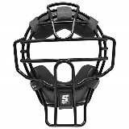
REQUEST FOR UMPIRES

DATE REQUESTED: _____/_____/_____

CLUB: ______________________________________________

AGE / GRADE: _________________________________________

GAME DATE: _________________________________________

TIMESLOT: _________________________________________

GAME: ________________ V __________________

DIAMOND: _________________________________________

Please email to umpires@sdsa.com.au no later than the Wednesday prior to the date required.

All requests are subject to umpire availability.

Note: $50 per game

Direct Deposit Details:
BSB: 062-196
Account Number: 10056315
Account Name: SDSA Umpires

Please send a copy of transaction receipt to: umpires@sdsa.com.au

OFFICE USE ONLY: (Treasurer)

Receipt No: ____________ Date: ________________

Signature: _____________________________________

